**Hotel Sales CRM User Manual**



Apoco Designs



**Table of Contents**

This manual assumes that you have at least basic knowledge of hotel sales and hotel operations. This manual was created for Directors of sales and General managers to familiarize themselves with the basic functions the Hotel Sales Customer Relationship Management (CRM) Software.

1. **Sales Terminology**
2. **Basic Navigation**
3. **Software Sales Pipeline**
4. **Create new**
   1. **Contact**
   2. **Company**
   3. **Lead**
5. **Contact**
   1. **Contact List**
   2. **View Contact**
   3. **Edit Contact**
6. **Company**
   1. **Company List**
   2. **View Company**
   3. **Edit Company**
7. **Leads**
   1. **Leads list**
   2. **View Lead**
   3. **Edit Lead**
8. **Local Negotiated Rate (LNR) Deals**
   1. **LNR Deal List**
   2. **Create New LNR Deal**
   3. **View LNR Deal**
   4. **Edit LNR Deal**
9. **Group Block Deals**
   1. **Group Block Deals List**
   2. **Create New Group Block Deal**
   3. **View Group Block**
   4. **Edit Group Block**
   5. **Add Group Block Details**
10. **Meeting Room Rental (MRR) Deals**
    1. **MRR Deals List**
    2. **Create New MRR Deal**
    3. **View MRR Deal**
    4. **Edit MRR Deal**

**1.0 Sales Terminology**

**LNR:** local negotiated rate. These are rates that are negotiated between an organization or company and the hotel. Basically the organization get a discount on hotel rooms because they bring X number of rooms per year to the hotel.

**Group Rate:** These are discounted rates when an organization need a large number of rooms over certain dates. Wedding blocks are typical example along with church retreats etc.

**PMS:** property management system. This is the on property information system for the hotel which is in charge of room management, reservations, accounting, and billing.

**CRS:** Central Reservation System. This is a system that a hotel brand uses that takes reservations from the hotel’s website, call centers and usually interfaces with other CRS and GDS systems then transfers that information to an individual hotel’s PMS system. The CRS is a middleman between GDS or customers and the PMS system.

**GDS:** global distribution system. This is another middle man that is hotel and hotel brand agnostic and many travel agents 3rd party bookings are made through a global distribution system which interfaces with a brand CRS system which then transfers the information to the hotel’s PMS system.

**MRR:** Meeting Room Rental, which is the rental of meeting space at a hotel.

**2.0 Basic Navigation**



Primary Navigation of the software is done through the navigation buttons at the top of the screen. The light blue and orange buttons navigate to the contact management functions of the software and the dark green buttons navigate to the Hotel Sales Deal functions of the software. The dark blue button indicates which part of the software you are currently in. In the case of the screenshot above we are currently working the lead function of the software.

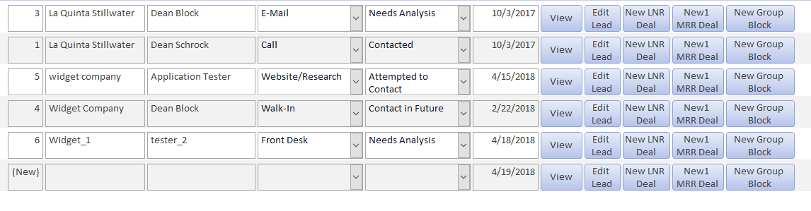

The software is made up of a series of lists which list all the customer and sales information contained within the software as seen above. Additional information can be shown about any piece of data in a list by clicking the view button which will navigate you to another screen with additional information about that item. If you need to change an item in a list simply click the Edit button and it will navigate you to a screen that will allow you to change data for that item.

In the Leads list you have additional buttons for leads that allow you to create a new LNR, MRR or Group Block deal from a lead. These buttons navigate you to a screen where you fill out additional information for that deal type.

 

Navigation inside of the various New, view and Edit functions is comprised of 4 main buttons. These buttons are Save, Update, Print and Back. Save button saves whatever information was entered into a form. The Update button similarly saves any changes made in an Edit form. The Print button allows you to print the data in the current form. The Back button allows you navigate to the previous screen. **It is important to always Save/Update any new information or changes to a form before navigating away from the form. If you navigate away from the form without saving or updating the information will be lost!**

**3.0 Software Sales Pipeline**

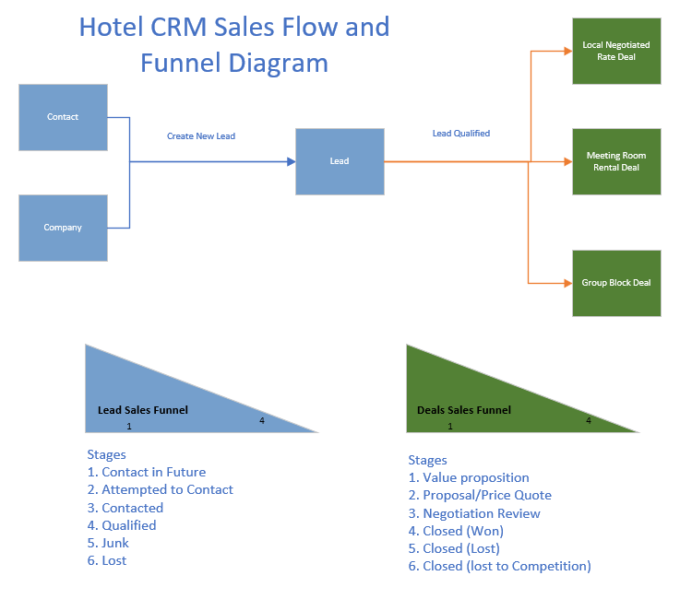

The Flow of information through the system starts with the creation of contact and company data. Once a contact or a company shows interest, or you know from research is a potential business opportunity the contact, company or combination of both become a lead and enter the leads sales pipeline. Leads sales funnel begins with Contact in Future and ends at either Qualified Junk or lost. As a lead moves from Contact in Future to Qualified it becomes more likely that the prospective customer will book business with the hotel. However, it at the same time more prospects drop out as they progress down the lead funnel and become either Junk or lost based on why they became disinterested in creating a deal with the hotel. Once a deal is qualified it should be converted to a deal and then enters the deal sales funnel. This starts at value proposition, which is were the hotel is talking to the client to gain enough information about the clients needs to create a quote. Once the hotel creates a quote and communicates that to the customer the deal stage becomes Proposal/Price Quote. The customer can either accept the quote unaltered which leads to Closed (Won) or they may request additional changes to the Quote, which is the Negotiation/Review Stage. Hopefully the potential client accepts the altered offer and it ends in Closed (Won) which means the hotel won the clients business. However, the client may not wish to due business with the hotel during any part of deal making process and they will drop out, Closed (Lost), or make a deal with a competing hotel, Closed (Lost to Competition). Just like the lead sales funnel as customer progresses through deal funnel customers drop out and the likelihood that a customer will book business with the hotel goes up.

**4.0 Create new**

**4.A Contact**



Create a new contact by first clicking on the new contact button.

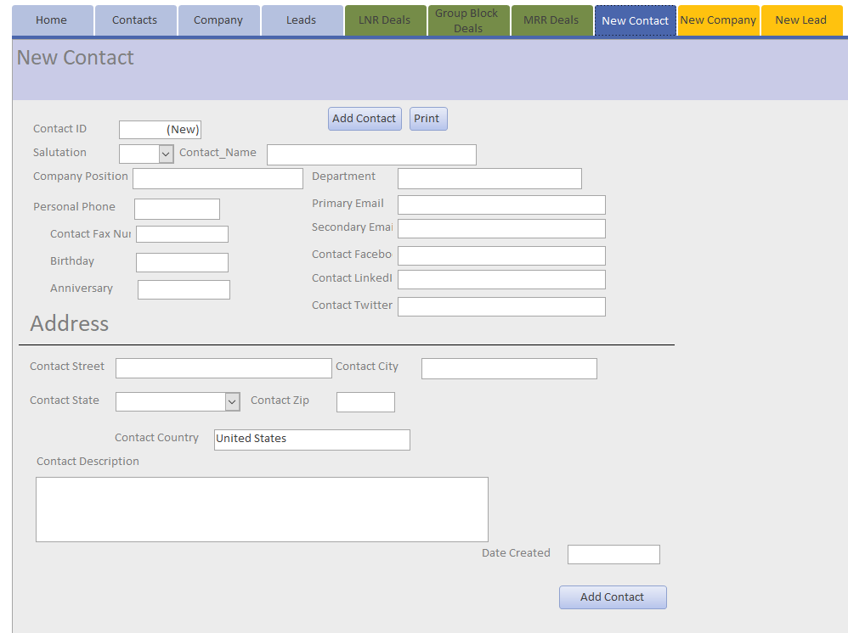

Then enter all of the new contact’s information. Make sure to create a contact name otherwise the software won’t allow you to save the new contact.

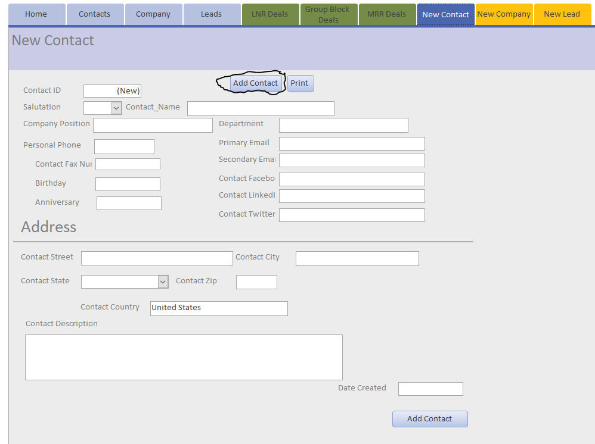

Click the Add Contact button and it will save the new contact. You can also print the new contact if you wish. Then you can navigate away from the create new form by clicking on any of the other top navigation buttons.

**4.B Company**



First Click the New Company Button.

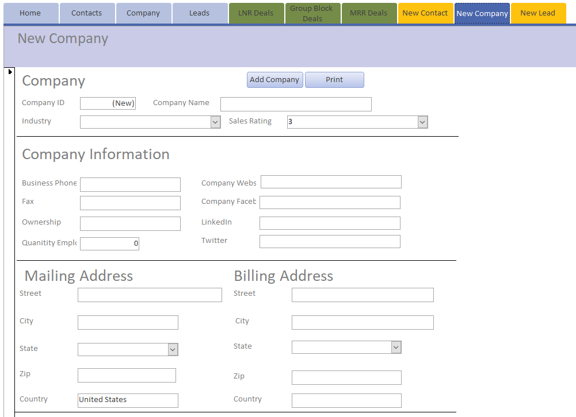

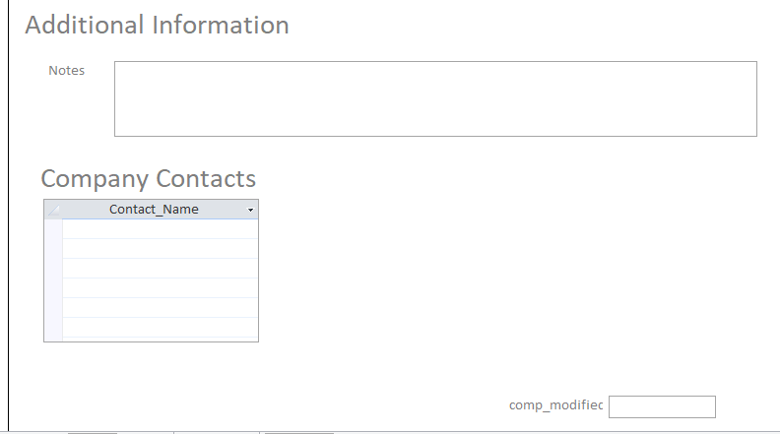

Then you can add all of the New Company Data. Make Sure you create a company name and if you find that you have multiple companies with the same name the company with the company city in the name.

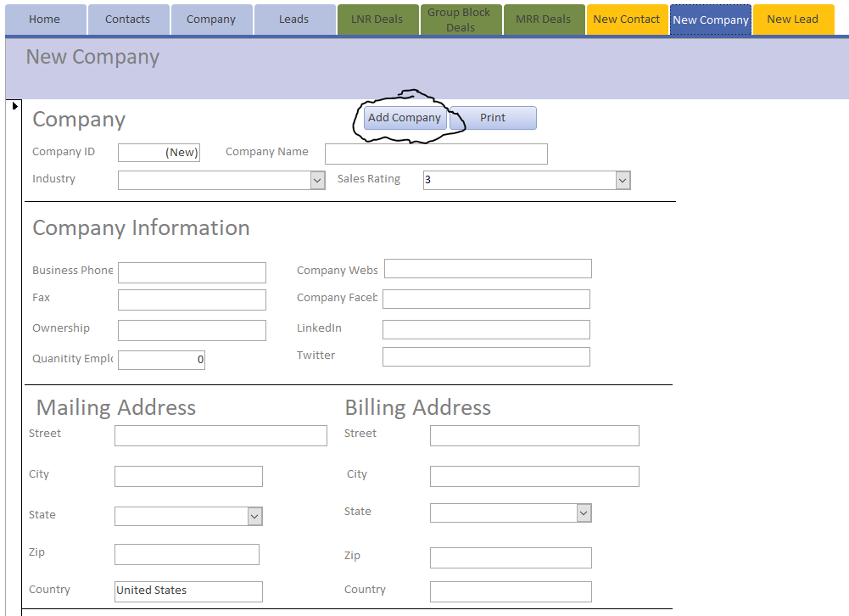

Once you are finished entering the company information click add company to save the company information. You can also print out the company information if you wish. You navigate away from the screen using the navigation button at the top of the screen.

**4.C Lead**



First Click the New Lead button.

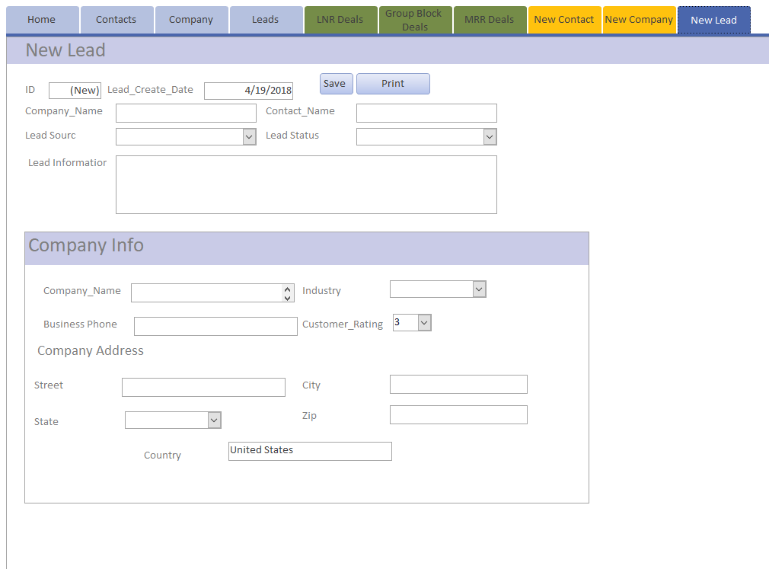

Then enter the Company and Contact name that you already and the Company Data will automatically populate the Company Information section of the form. Finish filling out Lead Source, Lead Status and Lead Information sections.

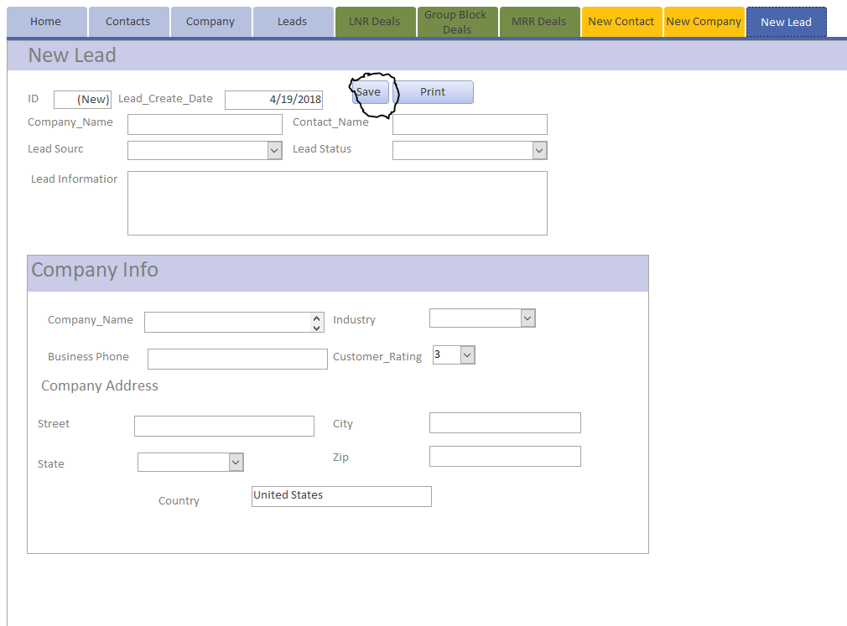

Save The form and navigate move on to doing something else in the software. You can also print the form from the new lead form. However, it is recommended to do this from the View leads form as it will contain more information about the lead.

**5 Contact**

**5.A Contact List**



Click the Contact button to navigate to the contact list. This lists all of the contacts that are in the system.

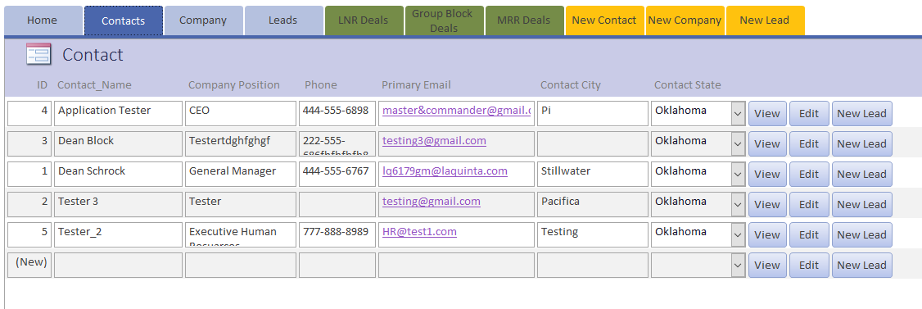

The Contact list gives you limited information about the contacts in the database. If you want to see more information about a specific contact simply click the view button on that contacts row. If you want to change the contacts data click the edit button. If you want to create a new lead using that contacts information click the new lead button.

**5.B View Contact**

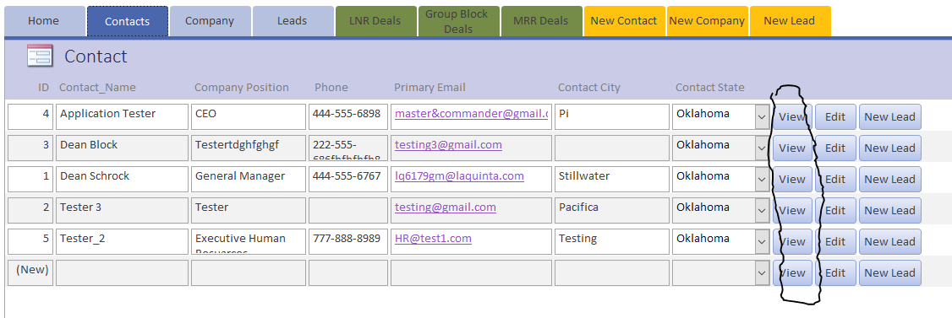

In order to view additional Contact information you will need to navigate to the contact list and then click the view button for the contact you are interested. This will let you see additional information about the contact.

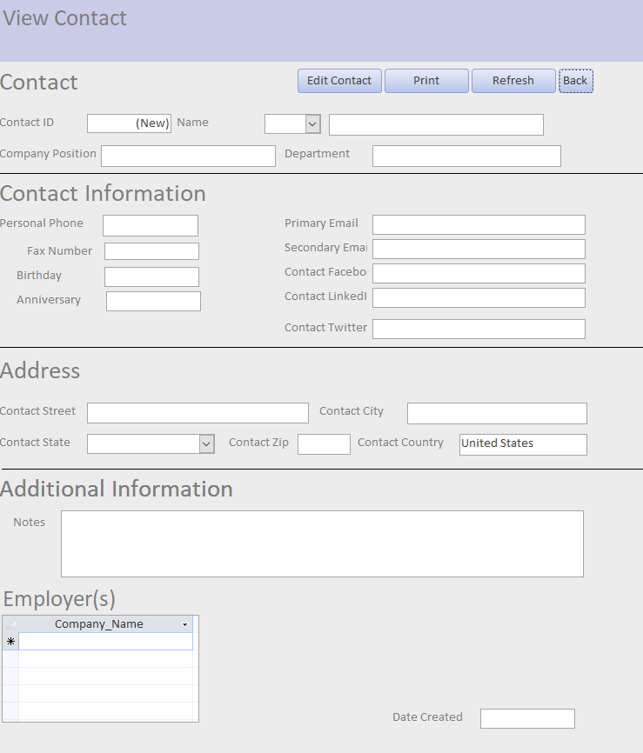

This lets you view all of the contact information for a specific contact.

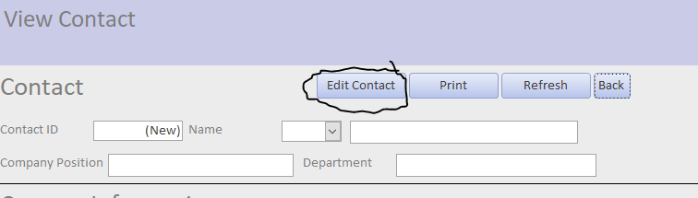

Click Edit Contact to edit the contacts information

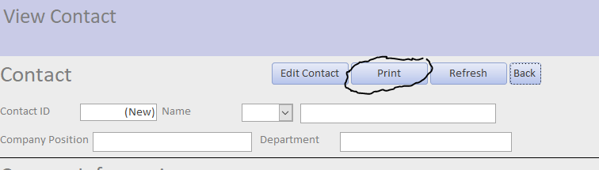

Click print to print the contact information

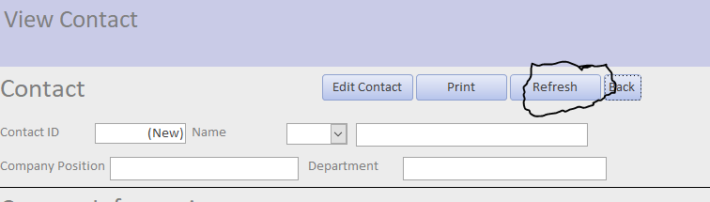

Click Refresh to ensure that the contact data is the current form of the data.

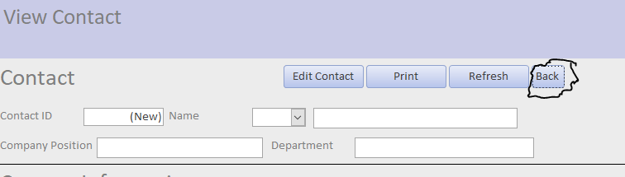

Click back to go back to the contact list

**5.C Edit Contact**

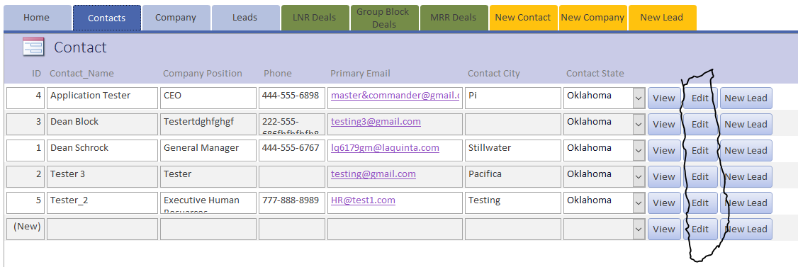

In order to Edit Contact information you will need to navigate to the contact list and then click the Edit button for the contact you are interested. This will let you Edit the contacts information.

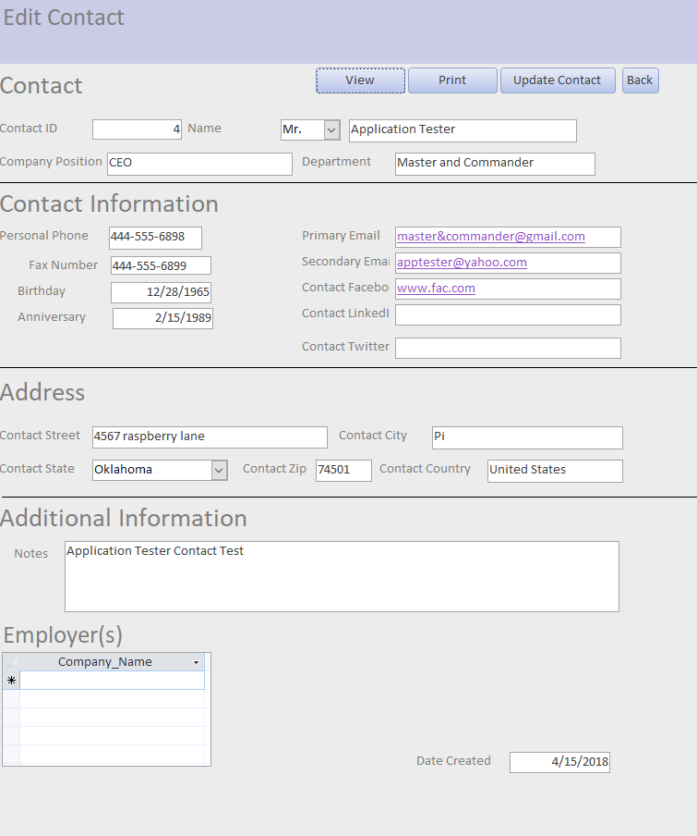

The Edit form allows you to change any of the contacts information.

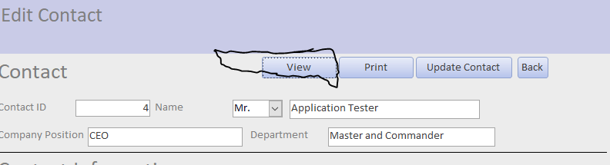

View button allows you to switch from Edit to view the form information.

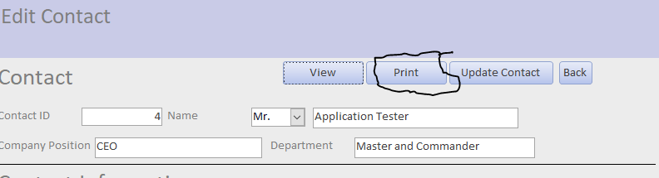

Print button allows you to print the updated contact information.

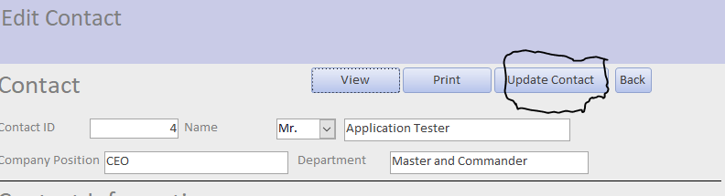

Update Contact button allows you to update the changed contact information. It is important to hit this button before navigating away from the Edit contact form.

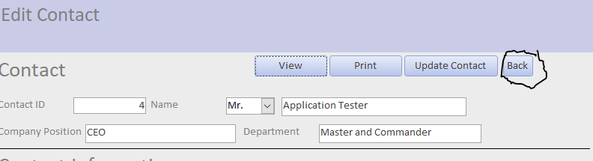

Back button takes you back to the Contact list.

**6 Company**

**6.A Company List**



The navigate to the company list click on the company button at the top of the navigation screen.

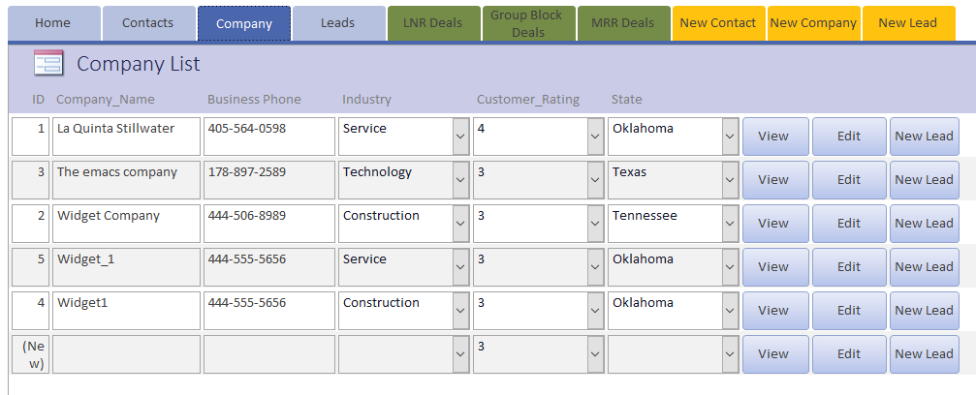

The Company list form lists all of the companies in the CRM software and allows you to View and Edit company data and also create New lead using the company data.

**6.B View Company**

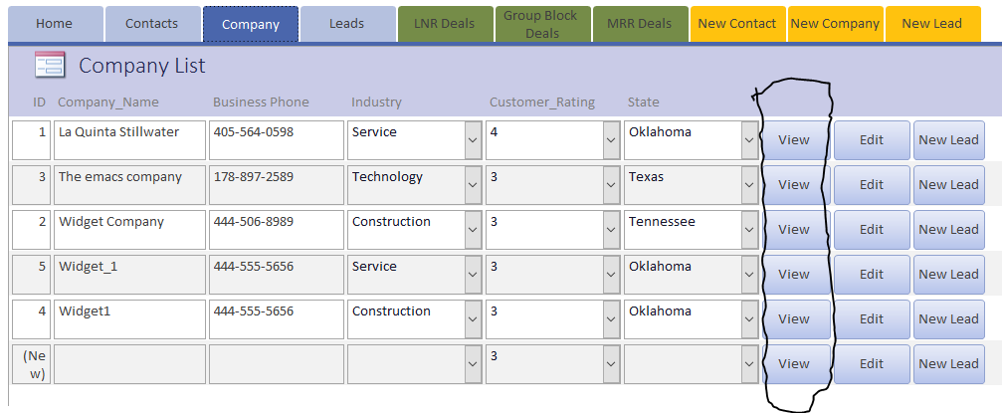

In order to view additional information about a specific company simply click the view button that corresponds to the company’s row.

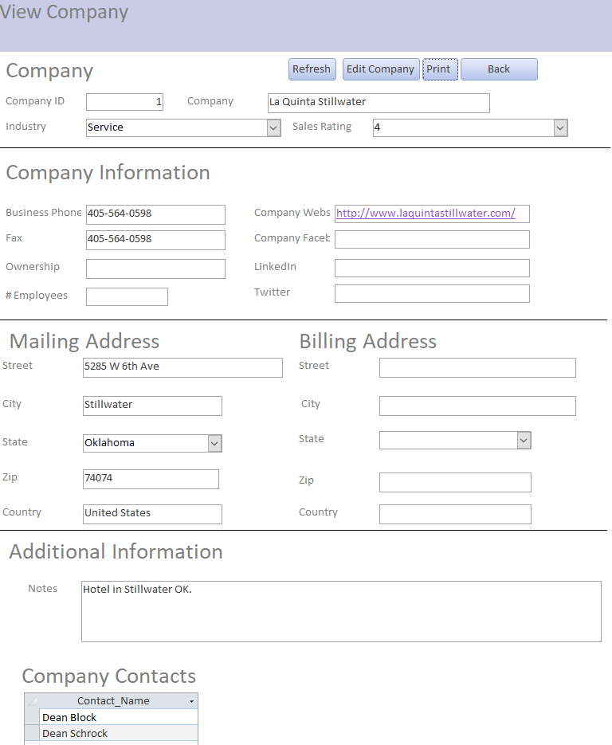

This navigates you to the view company form which shows all of the company data for the selected company.

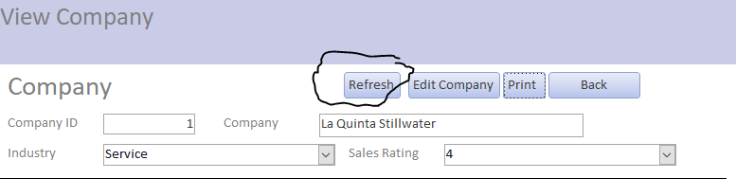

Refresh button allows you to makes sure you have the most up to date information about a company.

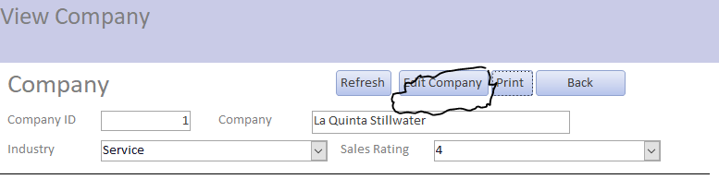

Edit button allows you to edit the company information.

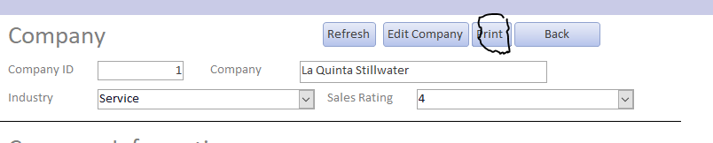

Print button allows you to print the company’s information.

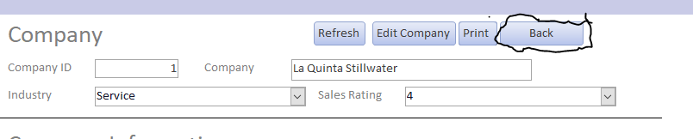

The back button allows to navigate back to the company list.

**6.C Edit Company**

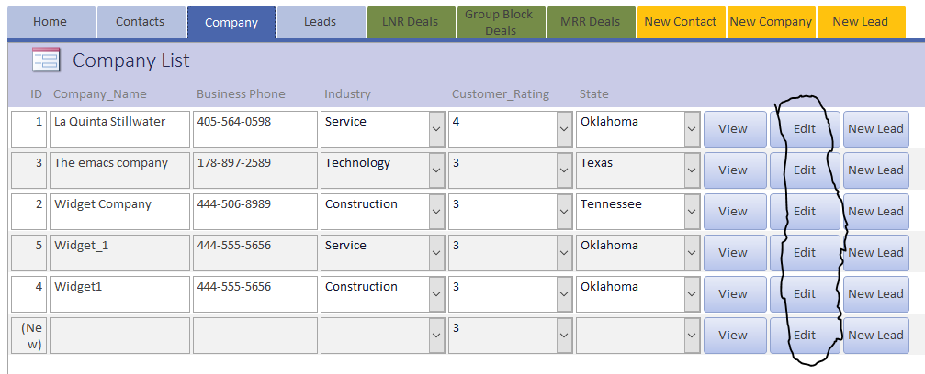

To Edit information about a specific company simply click the Edit button that corresponds to the company’s row.

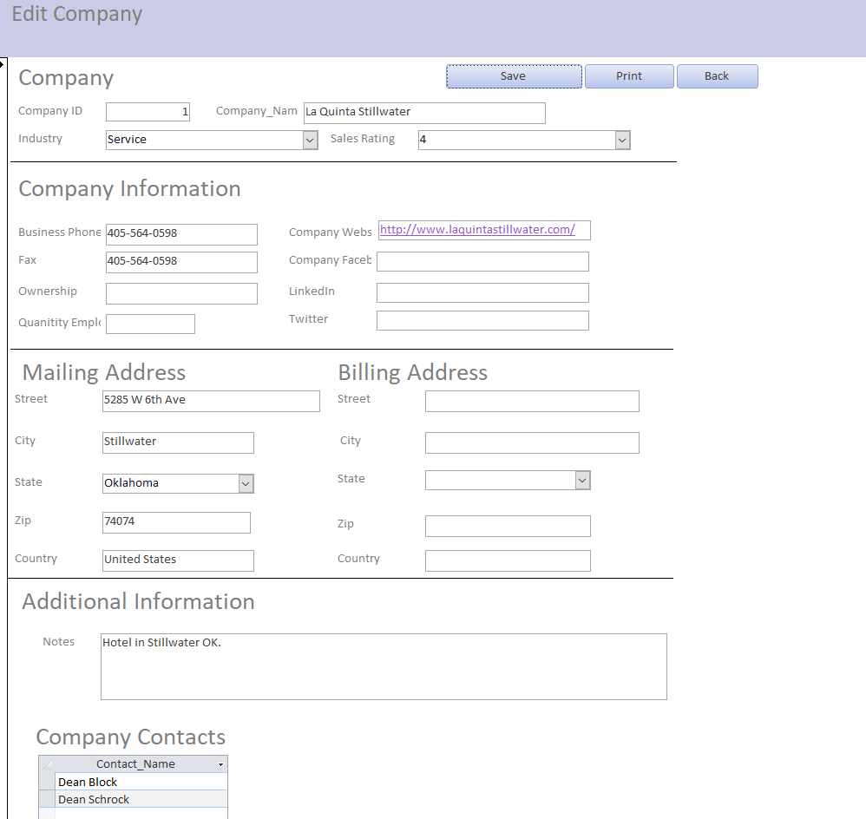

You now are at a screen that allows you to edit any of the company information.

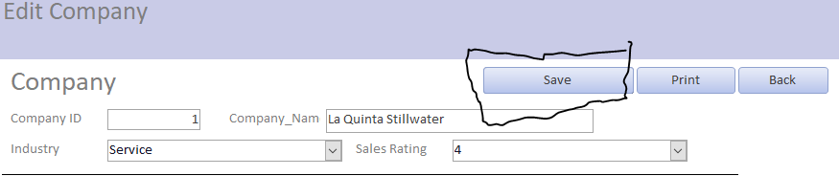

Save button allows you to save changes made to company’s information.

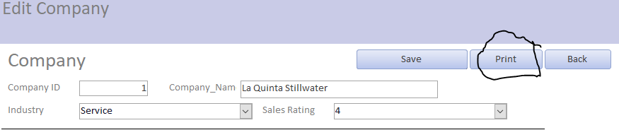

Print button lets you print updated company information.

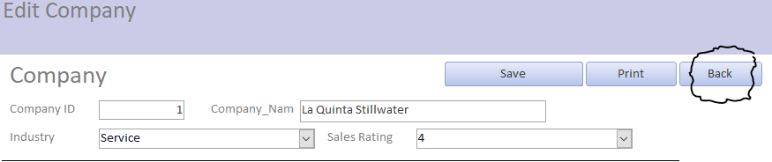

Back button navigates back to the company list form.

**7.0 Leads**

**7.A Leads list**



To navigate to the leads list click the leads button.

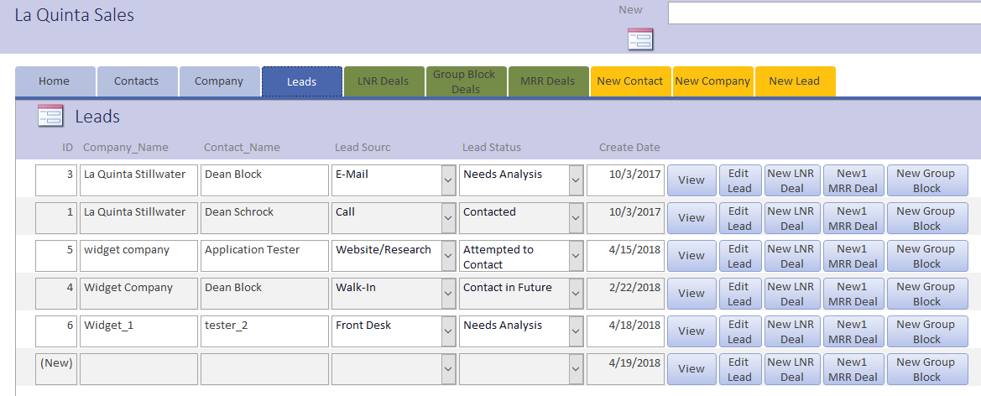

The Leads lists shows all of the leads that are currently in the CRM system. You have the ability to view additional information about lead or edit a lead. Additionally since lead is the transition between the contact management and deal management sides of the software you are also able to create LNR, MRR and Group Block from a lead.

**7.B View Lead**

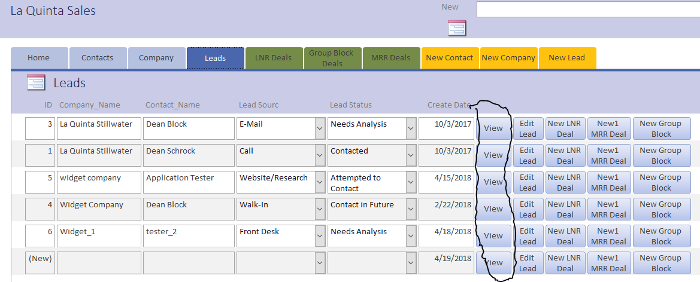

View lead information for a specific lead click the view button that corresponds to the lead row.

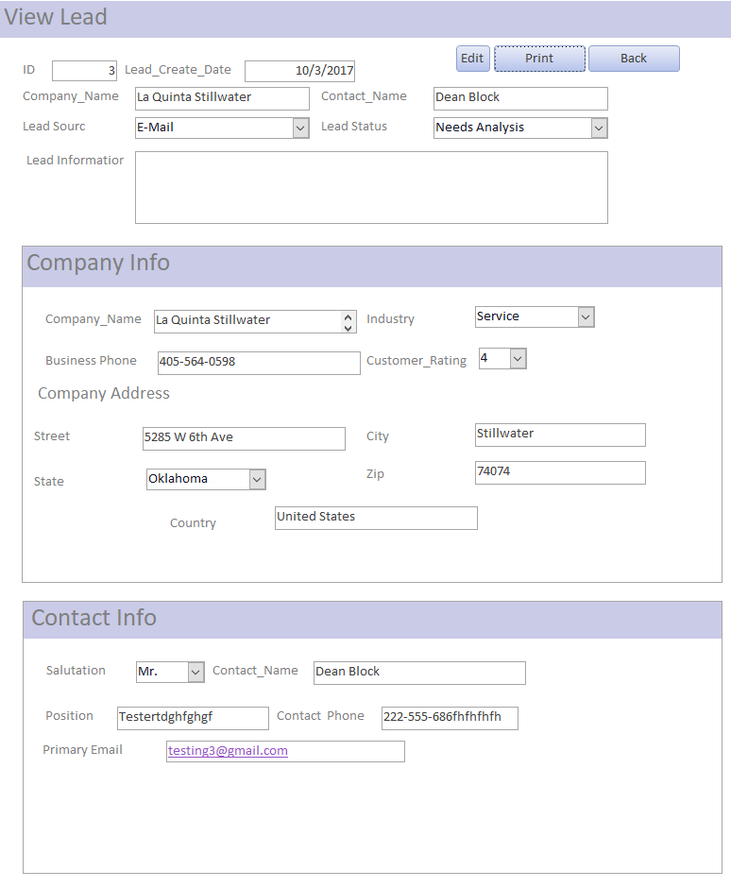

This allows you to view additional information about the lead

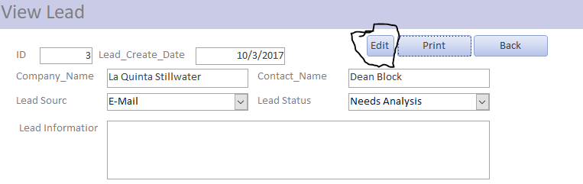

Edit button allows you to edit the lead information.

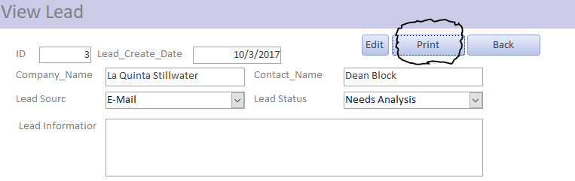

Print button allows you to print the lead information.

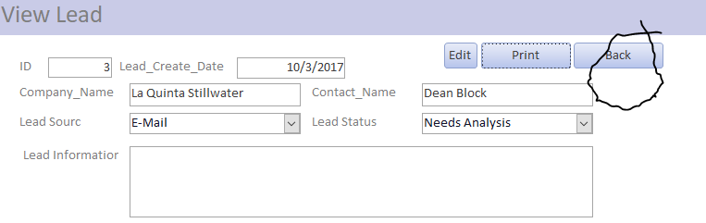

Back button navigates you back to the leads list form.

**7.C Edit Lead**

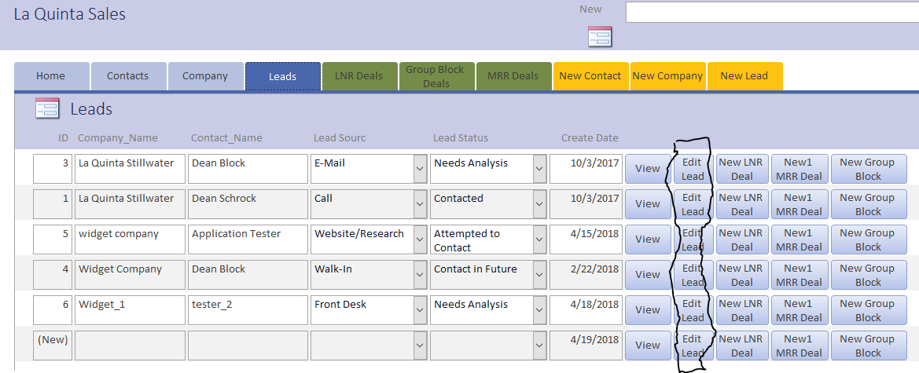

Edit lead information for a specific lead click the Edit button that corresponds to row you are interested in.

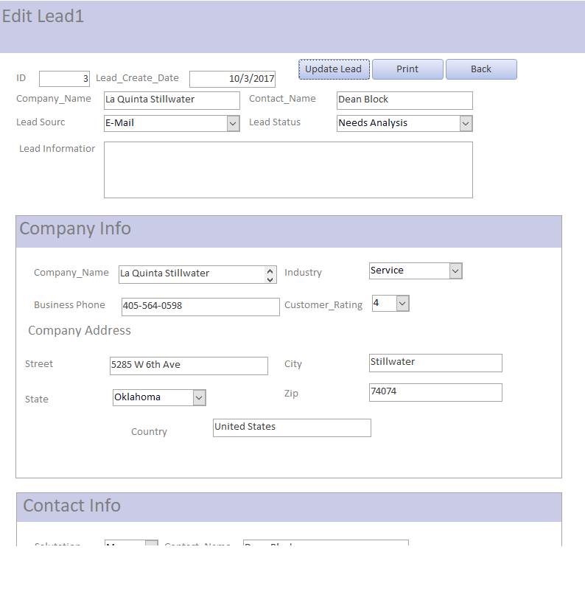

This allows you to edit the lead information. You cannot edit the company or contact information from this screen. To do that you need to update the information in the edit company or contact form.

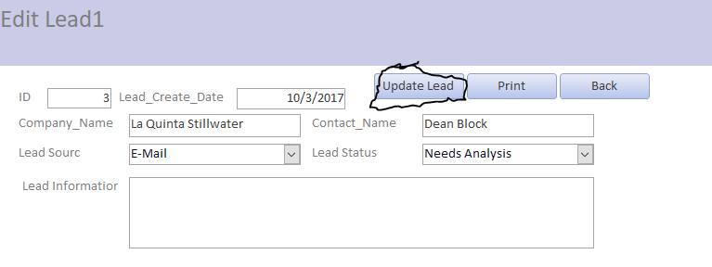

Update lead button saves the changes you made to the lead. It is important to save your changes before you navigate away from the form.

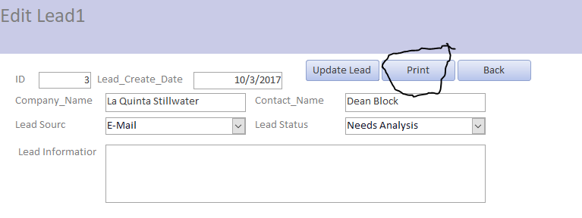

Print button allows you to print the update lead information.

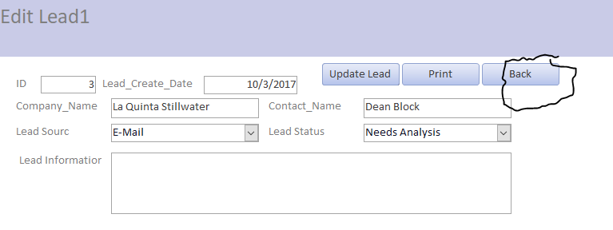

Back button navigates back to the lead list form.

**8.0 Local Negotiated Rate (LNR) Deals**

**8.A LNR Deal List**



To navigate to the LNR deal list click on the LNR Deals button on the top navigation menu.

**8.B Create New LNR Deal**



Navigate to leads list by clicking the leads button.

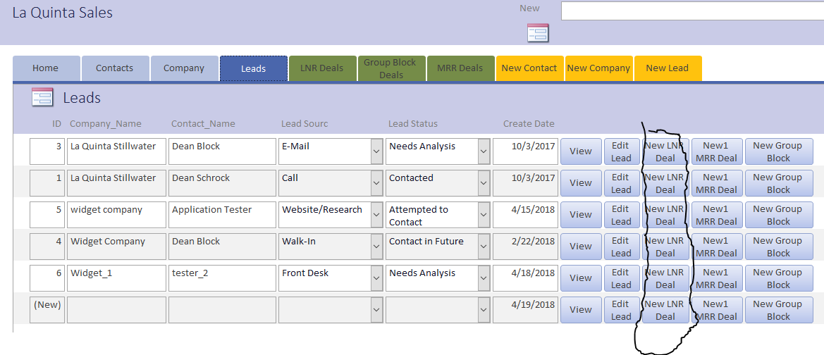

Click New LNR Deal button for the lead for which you want to create a new LNR Deal.

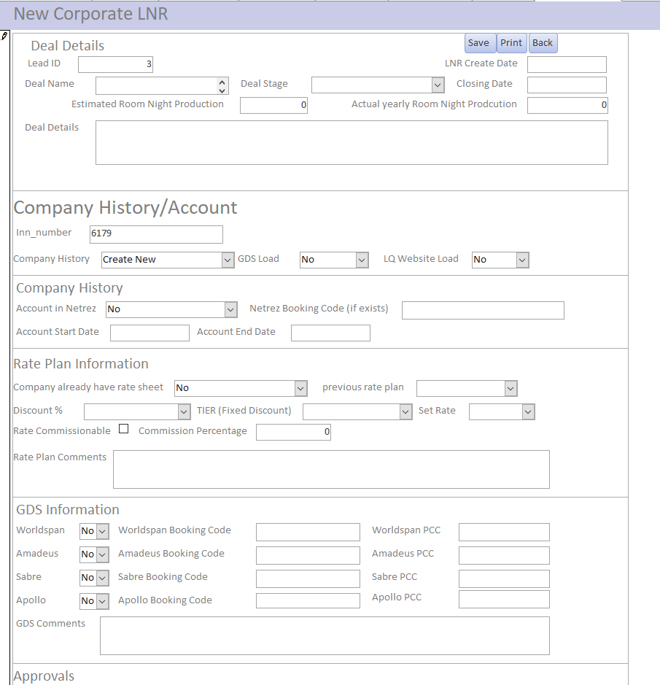

Fill out the information needed to complete the New LNR Deal.

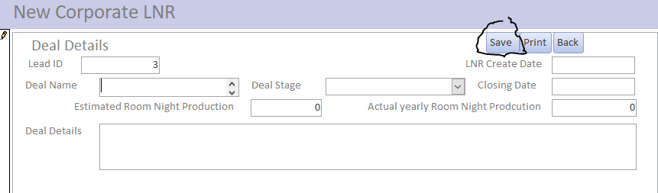

Click the save button to save the new LNR Deal

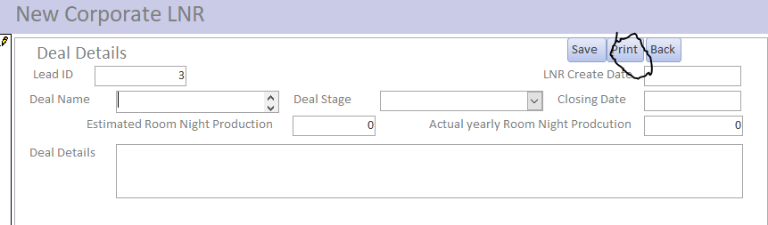

Click print button to print the new LNR Deal.

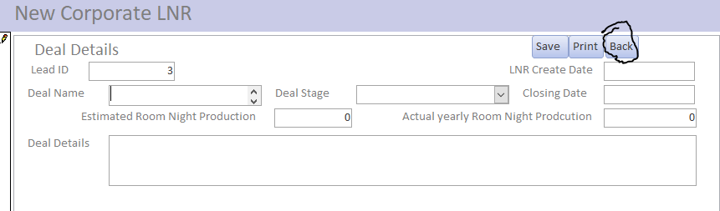

Click back button to navigate to the leads list.

**8.C View LNR Deal**

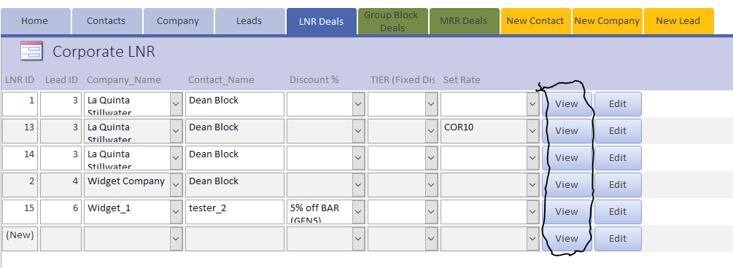

From the LNR Deals list click the view button for the LNR Deal that you want to view additional details about the Deal.

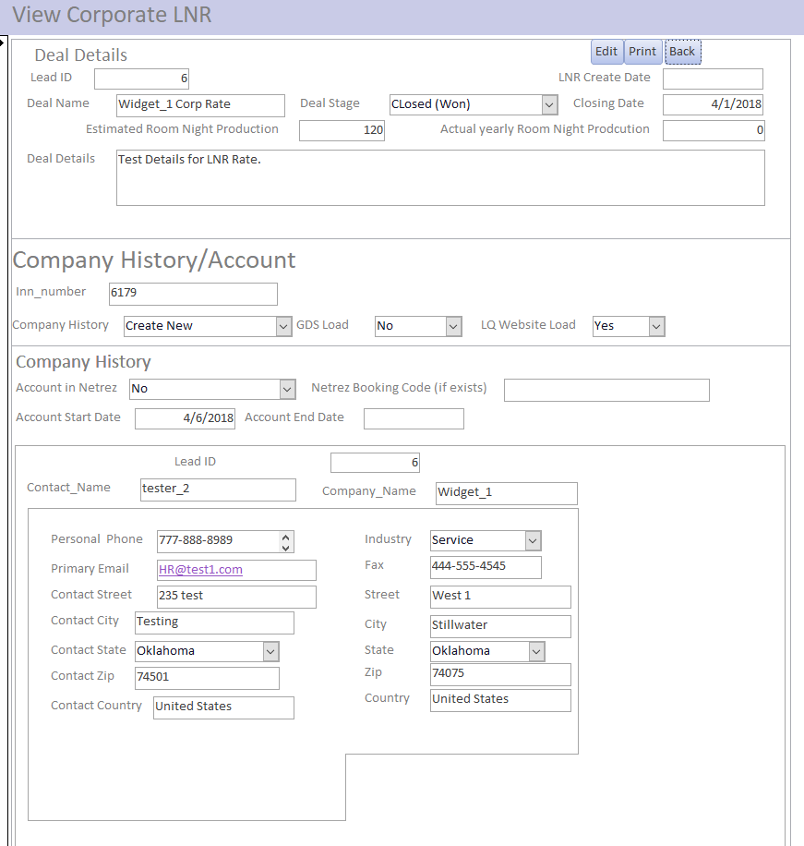

Now you can view details about corporate LNR Rate.

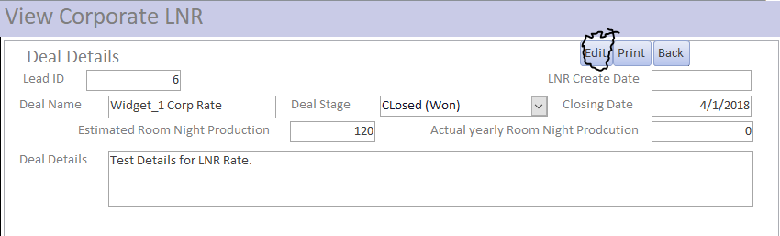

Click edit button to change details about the corporate LNR Rate.

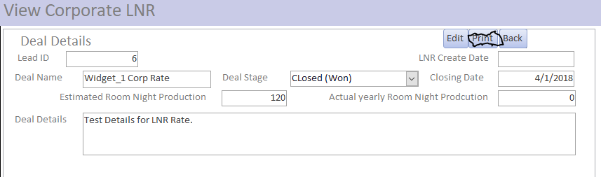

Click print button to print LNR deal information.

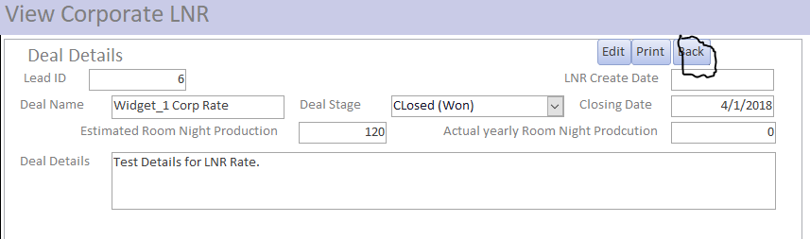

Click the back button to navigate back to the LNR Deals list.

**8.D Edit LNR Deal**

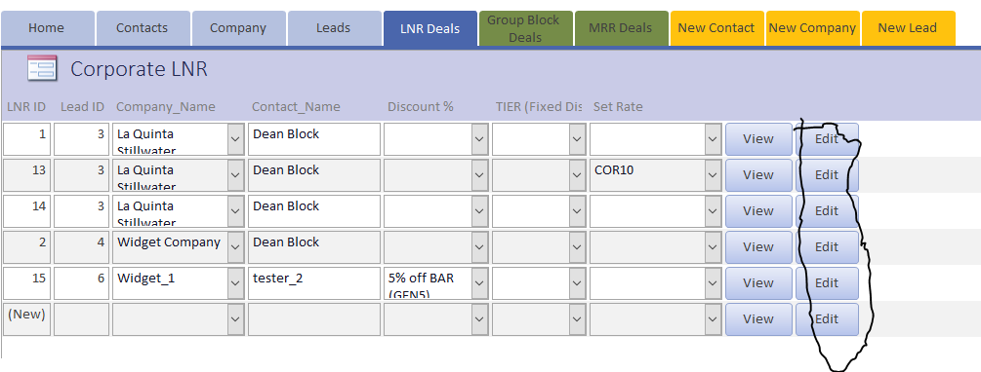

From the LNR Deals list click the Edit button for the LNR Deal that you want to Edit details about the Deal.

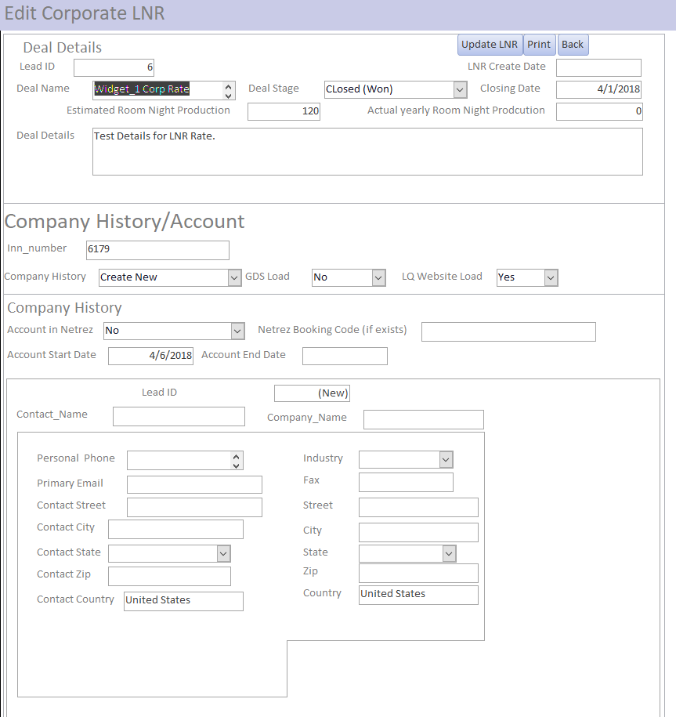

You can now edit any information about the LNR Deal. However you cannot edit lead, company or contact information. In order to edit that information go to the respective editing forms.

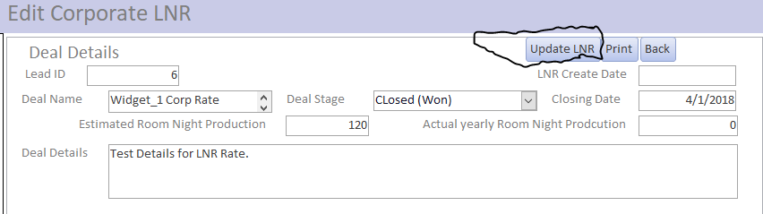

The update LNR button save the changes made to the LNR Deal, make sure to push this button if you make any changes before you navigate away from this page to ensure that the data is saved.

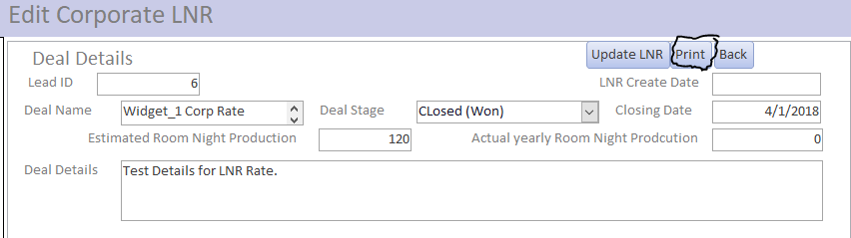

The print button prints the updated LNR Deal information.

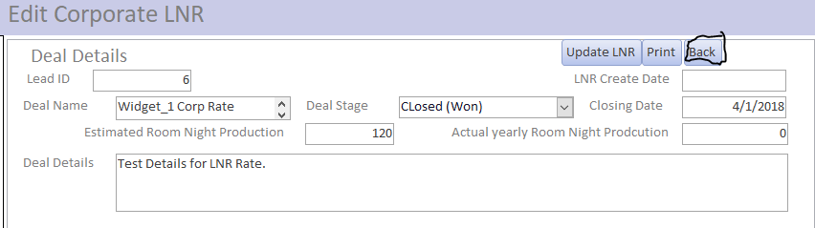

Back button navigates back to the LNR Deals list.

**9.0 Group Block Deals**

**9.A Group Block Deals List**



To navigate to the Group block Deals list click the Group Block Deals button on the top navigation menu.

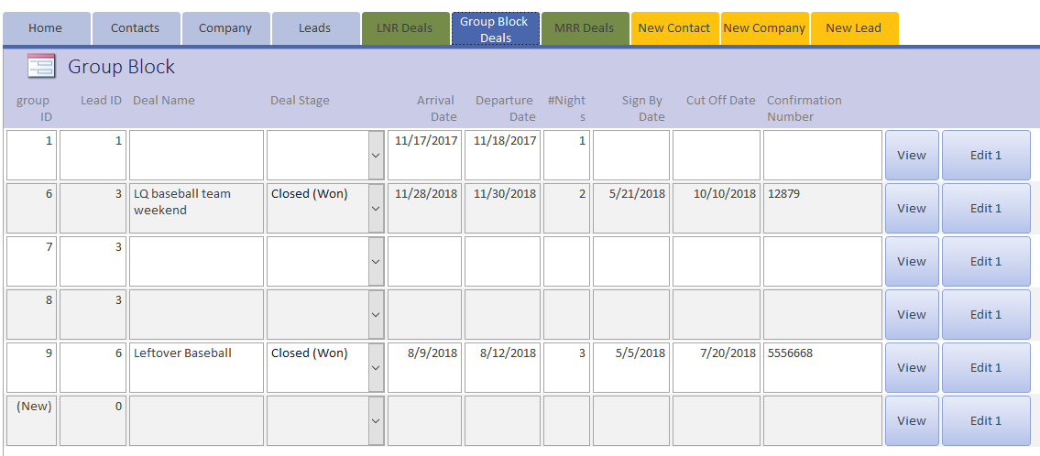

The Group Block Deals list shows all of the Group Block Deals that are saved in the system.

**9.B Create New Group Block Deal**



Click the leads button to navigate to the leads list.

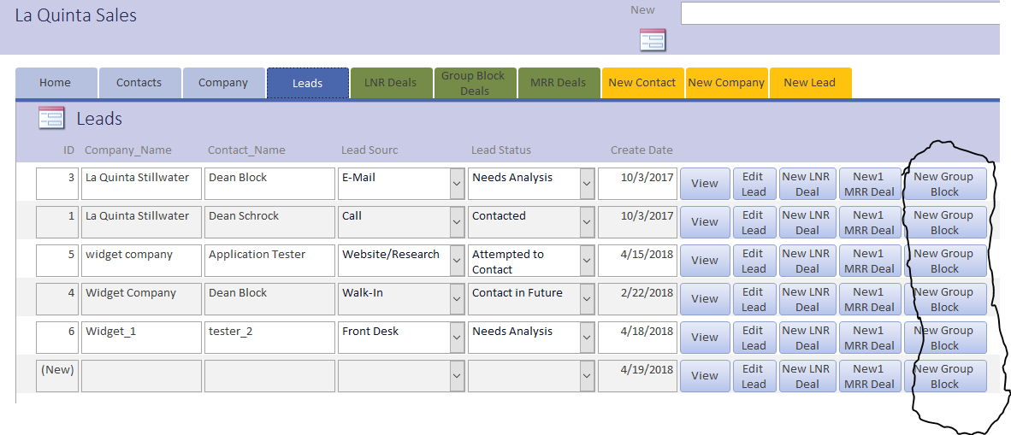

Click the new group block button for the lead you wish to convert into a new group block.

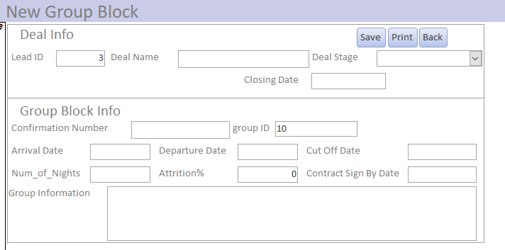

Input the relevant group block information. Always input a deal name so you can easily recognize the deal in the future.

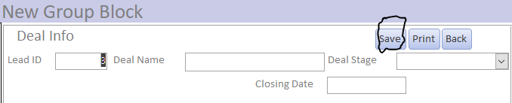

Click save to save the new group block.

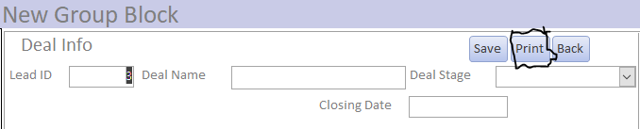

Click print to print the new Group Block Deal Information.

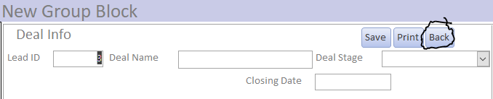

Click the back button to navigate to the Leads list form.

**9.C View Group Block**

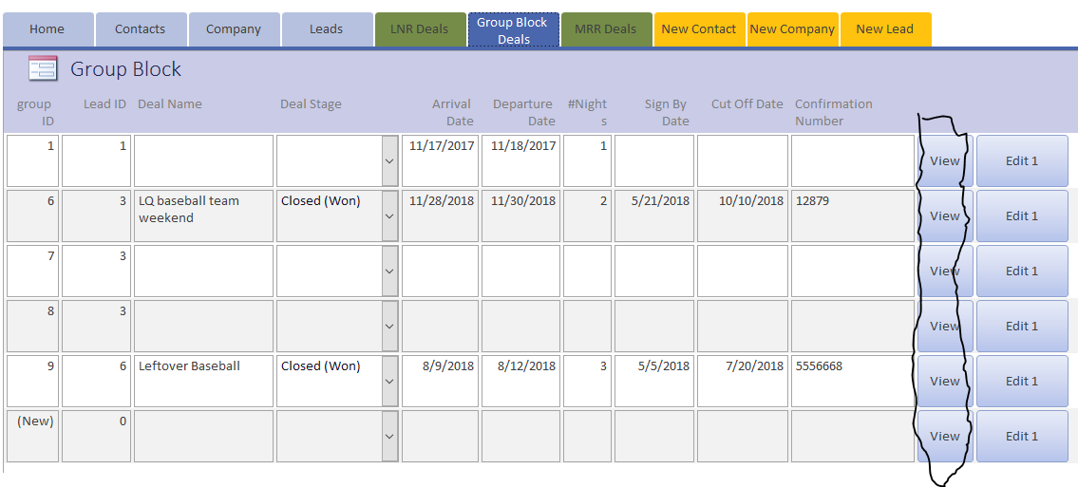

Click the view button for the group block you wish to view.

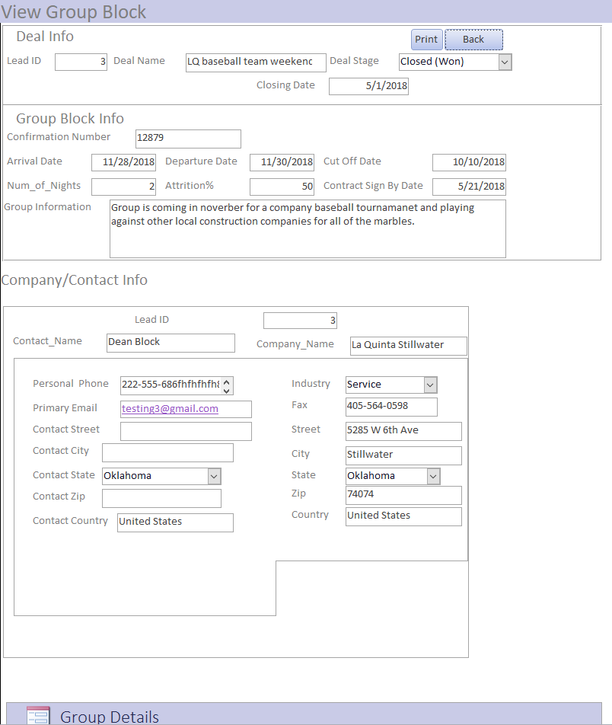 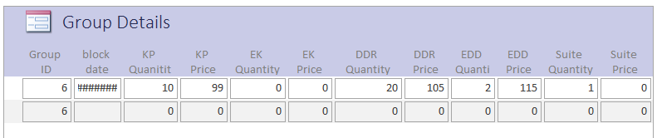

Now you can view all of the details for the Group Block Deal.

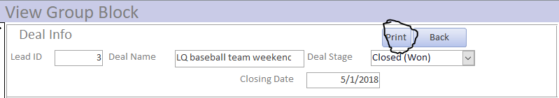

Click the print button to print the Group Block deal data.

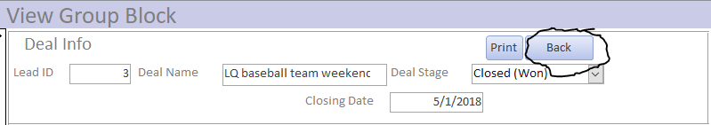

Click the back button to navigate back to the Group Block List form.

**9.D Edit Group Block**

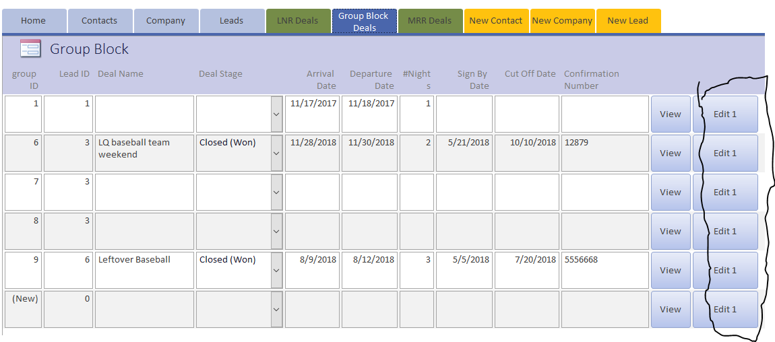

Click the Edit button for the group block you wish to Edit.

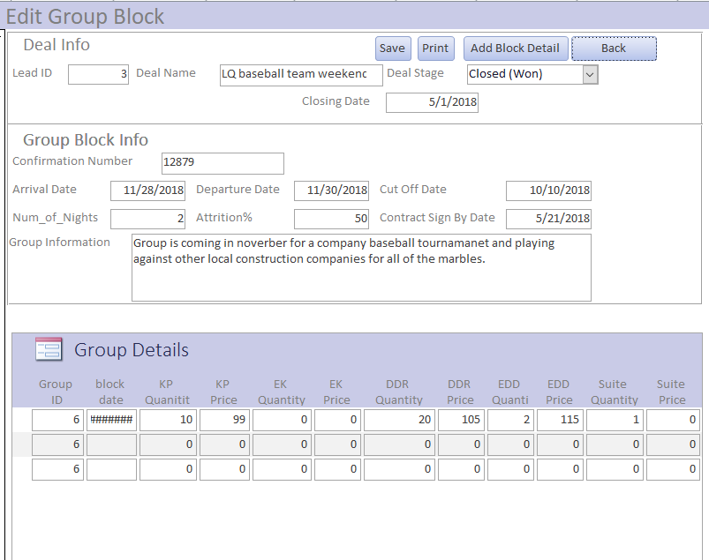

Now you can edit whatever Group block information you need.

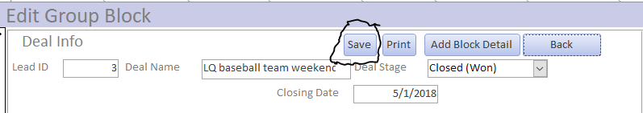

Click save to save any changes made to the Group block deal.

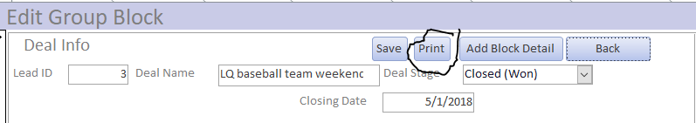

Click print to print the updated Group Block Deal.

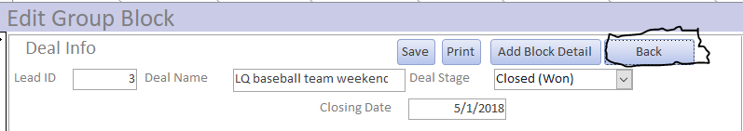

Click back to navigate to the Group block Deal List.

**9.E Add Group Block Details**

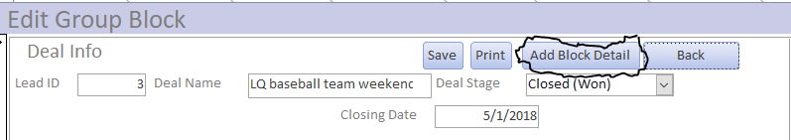

From the Edit group block form click the Add Block Detail Button.

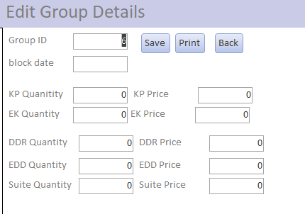

Then you can input all of the room information for a single night. This means that for Group blocks that span multiple nights you will have to repeat the Add group block detail for each night the group will be at the hotel.

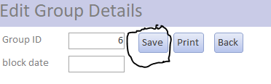

Save button saves the new Group details

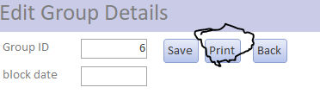

Print button prints the new group detail.

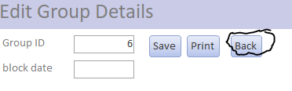

Back button navigates you to the previous Edit Form.

**10.0 Meeting Room Rental (MRR) Deals**

**10.A MRR Deals List**



To navigate to the MRR Deals list click the MRR Deals button.

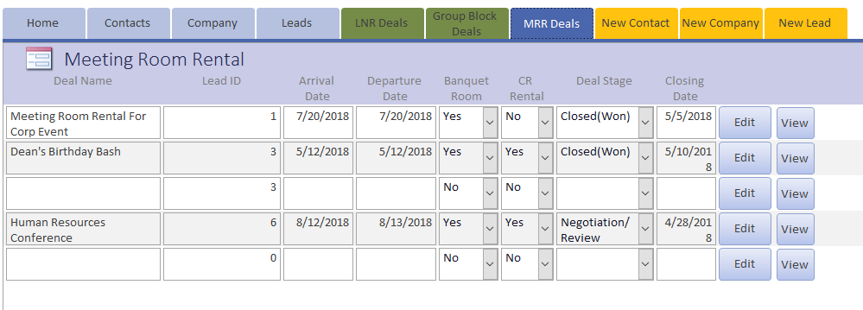

The MRR Deals list shows all of the Meeting Room Rental (MRR) Deals that are currently in the system.

**10.B Create New MRR Deal**



Navigate to the Leads list by clicking on the leads button.

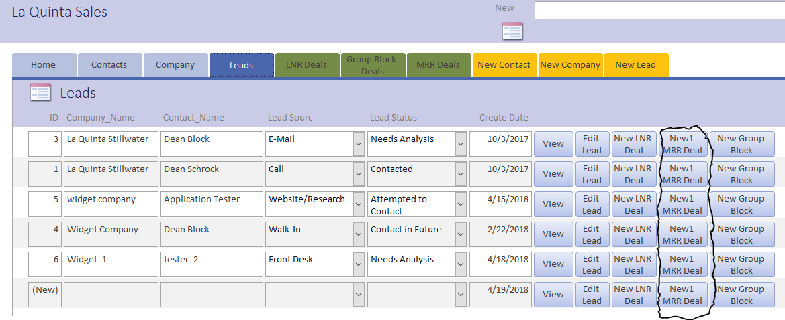

Click the New1 MRR Deal button for the lead you wish to convert to a new MRR Deal.

**10.C View MRR Deal**

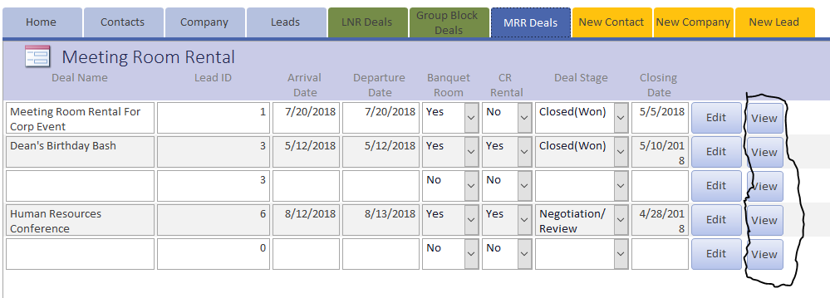

Click the View button for the MRR Deal you wish to View the deal details.

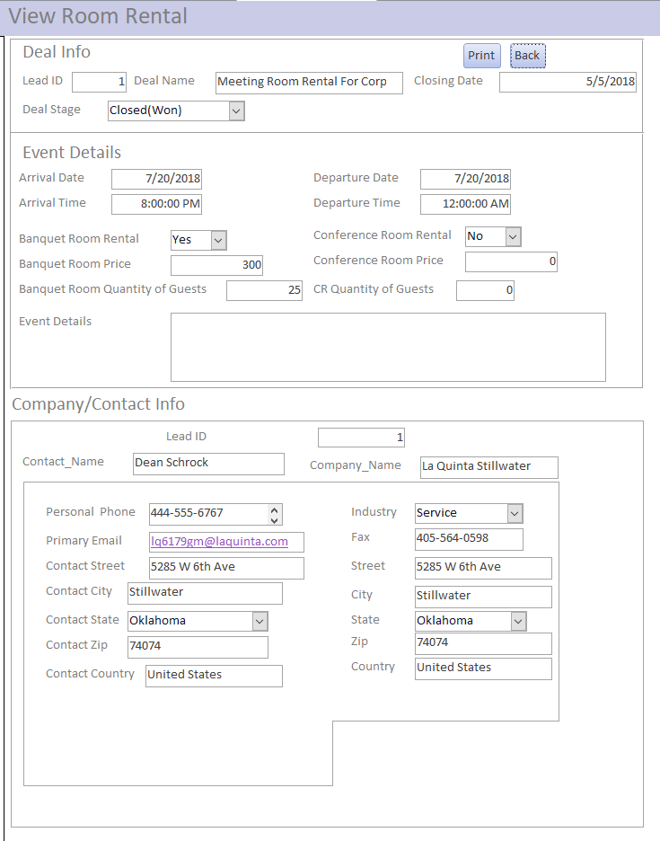

Now you can view all of the MRR deal information.

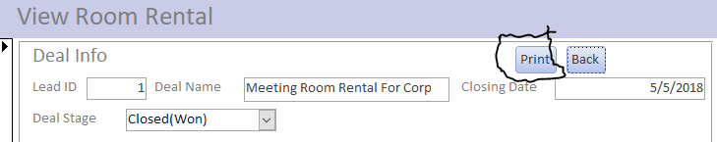

Click the print button to print the MRR Deal information.

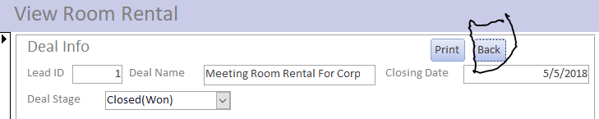

Click the back button to navigate to the MRR deals list.

**10.D Edit MRR Deal**

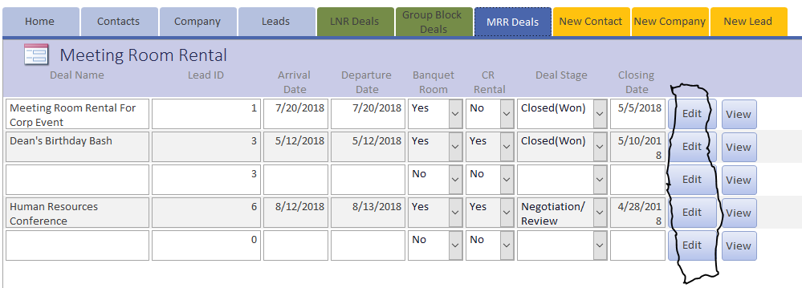

Click the Edit button for the MRR Deal you wish to Edit.

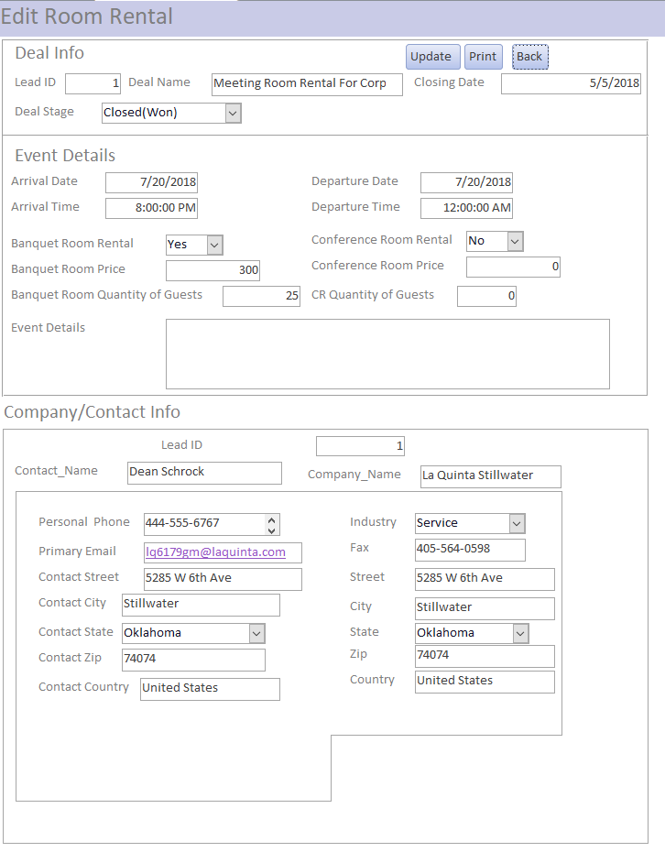

Now you can edit any MRR Deal information needed.

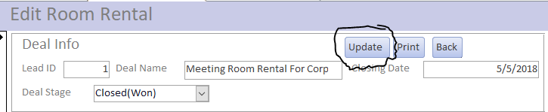

Click the Update button to save the changes to the MRR deal. Make sure to always click the save button after making any changes and before you navigate to another screen to ensure that the new updated information is not lost.

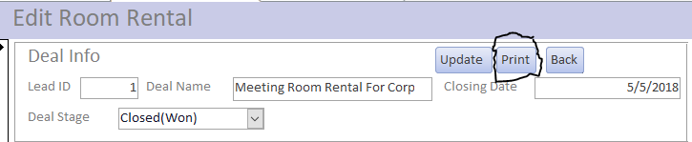

Click the print button to print the updated MRR Deal information.

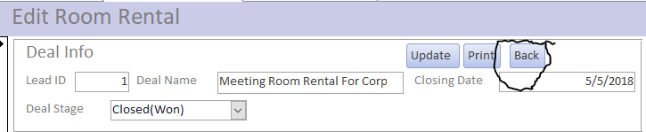

Click the back button to navigate to the MRR Deals list form.